**Project 2 Part 2 (square with min area)**

Name: Ramya Reddy Period: 4

Date: 10/08/21

Is your lab name l022?(lowercase L followed by digits 022) Yes

Did you comment out the call to part1 method? Yes

Did you create a class for a Point? Yes

Did you create a class for a Line? Yes

List all classes you created in this project: Point, Line, Graph

Did you use the precision for the points like in the sample? Yes

Did you test your file on a school computer using jupyterhub/ssh? Yes

Did your file compile and run on school computer (jupyterhub)? Yes

Paste here **2 sets of clear picture/content** of the points.txt, output.txt and output.ppm you created when running 2 times your lab :

* one of the runs should be on the sample provided by Mr. Jurj;

points.txt :

(0.18161564989165929,0.49650563066499831) , (0.20331431012909329,0.66115298928800315) , (0.45457319864497819,0.36802270577105012) , (0.86330759605700857,0.82033753471480453)

output.txt:

(0.18161564989165929,0.49650563066499831) , (0.20331431012909329,0.66115298928800315), (0.45457319864497819,0.36802270577105012) , (0.86330759605700857,0.82033753471480453)

(0.34174493950384799,0.28328741002475755) , (0.43467909320732401,0.35308200810630136) , (0.27195034142230529,0.37622156372823184) , (0.36488449512578119,0.44601616180977627) Area = 0.01350804284594554

(0.58863052673951866,0.28691864991369798) , (0.66019192383416969,0.42588984517177741) , (0.44965933148143944,0.35848004700834923) , (0.52122072857609081,0.49745124226642840) Area = 0.02443402666559757

(0.11723405021564327,0.61397476973488152) , (0.27298780221724145,0.69933911128708115) , (0.20259839176784403,0.45822101773328150) , (0.35835214376944197,0.54358535928548157) Area = 0.03154630207121596

(0.27776345099379907,0.94567679589967168) , (0.56505963794640368,0.88417931169208619) , (0.21626596678621329,0.65838060894706674) , (0.50356215373881763,0.59688312473948013) Area = 0.08632103960136817

(0.26976728773113040,0.54851018465181811) , (0.30404636140174390,0.49040457166164952) , (0.32787290072129666,0.58278925832243056) , (0.36215197439191033,0.52468364533226197) Area = 0.00455131715267860

(0.42218393076071886,0.54143740665515017) , (0.38671828307155143,0.73132328822726134) , (0.23229804918860925,0.50597175896598356) , (0.19683240149944228,0.69585764053809485) Area = 0.03731446018642998

output.ppm

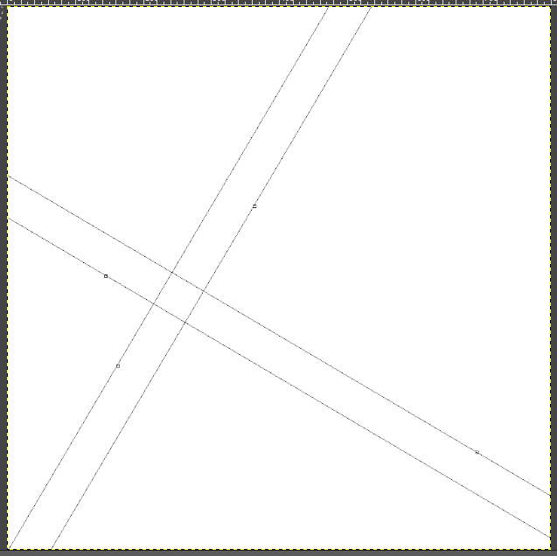

* the other run on a random set of points.txt your part1 generated!! :

points.txt:

(0.21067815563207407,0.699722392344718) , (0.04724175997415640,0.71075947243289994) , (0.36716406716367417,0.98408071882281489) , (0.73425084386684503,0.64550364652904857)

output.txt:

(0.18161564989165929,0.49650563066499831) , (0.20331431012909329,0.66115298928800315), (0.45457319864497819,0.36802270577105012) , (0.86330759605700857,0.82033753471480453)

(0.34174493950384799,0.28328741002475755) , (0.43467909320732401,0.35308200810630136) , (0.27195034142230529,0.37622156372823184) , (0.36488449512578119,0.44601616180977627) Area = 0.01350804284594554

(0.58863052673951866,0.28691864991369798) , (0.66019192383416969,0.42588984517177741) , (0.44965933148143944,0.35848004700834923) , (0.52122072857609081,0.49745124226642840) Area = 0.02443402666559757

(0.11723405021564327,0.61397476973488152) , (0.27298780221724145,0.69933911128708115) , (0.20259839176784403,0.45822101773328150) , (0.35835214376944197,0.54358535928548157) Area = 0.03154630207121596

(0.27776345099379907,0.94567679589967168) , (0.56505963794640368,0.88417931169208619) , (0.21626596678621329,0.65838060894706674) , (0.50356215373881763,0.59688312473948013) Area = 0.08632103960136817

(0.26976728773113040,0.54851018465181811) , (0.30404636140174390,0.49040457166164952) , (0.32787290072129666,0.58278925832243056) , (0.36215197439191033,0.52468364533226197) Area = 0.00455131715267860

(0.42218393076071886,0.54143740665515017) , (0.38671828307155143,0.73132328822726134) , (0.23229804918860925,0.50597175896598356) , (0.19683240149944228,0.69585764053809485) Area = 0.03731446018642998

output.ppm:

